Circuit Analysis
Lab 7
Assignment

Submitted by:
Wardah Shahid
2025-CE-81

University of Engineering
and Technology

For Inverting:
Circuit:
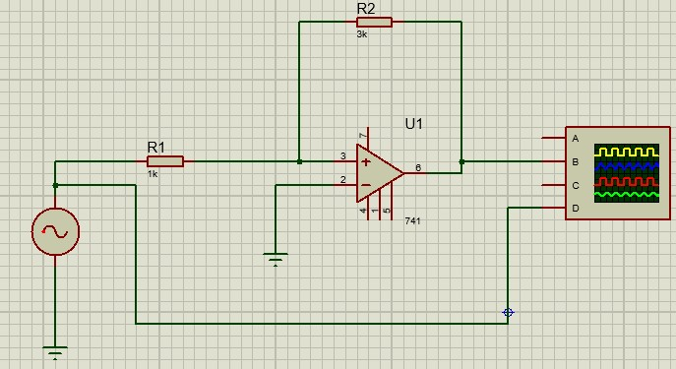
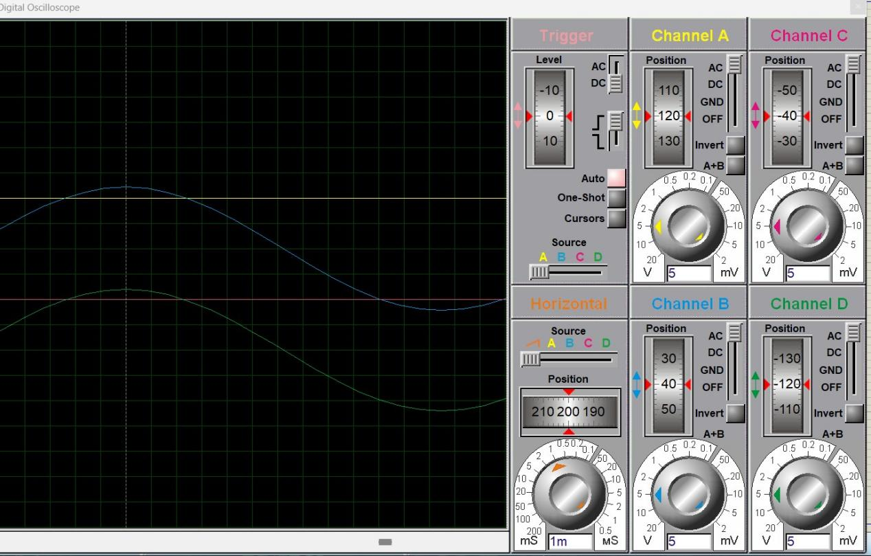

Explanation:
• This is an Op-Amp (741) based circuit
• An AC input signal (sine wave) is applied at the left side
• R1 (1kΩ) is the input resistor
➤ It feeds the signal to the non-inverting (+) terminal of the op-amp
• The inverting (–) terminal is connected to ground
• R2 (3kΩ) is connected from output back to the + terminal
➤ This is called positive feedback
• Due to positive feedback, the circuit behaves like a Schmitt Trigger (comparator with hysteresis)
• Working:
- When input voltage exceeds a certain upper threshold, output goes to positive saturation (HIGH)
- When input drops below a lower threshold, output goes to negative saturation (LOW)
• Because of this switching:
- Input = sine wave
- Output = square wave
• The right-side display shows the waveforms on an oscilloscope
• Purpose of the circuit:
➤ Convert an analog signal into a digital (square) signal
• Role of R1 and R2:
➤ They set the threshold levels (hysteresis) at which the output switches
For Non-Inverting
Circuit:
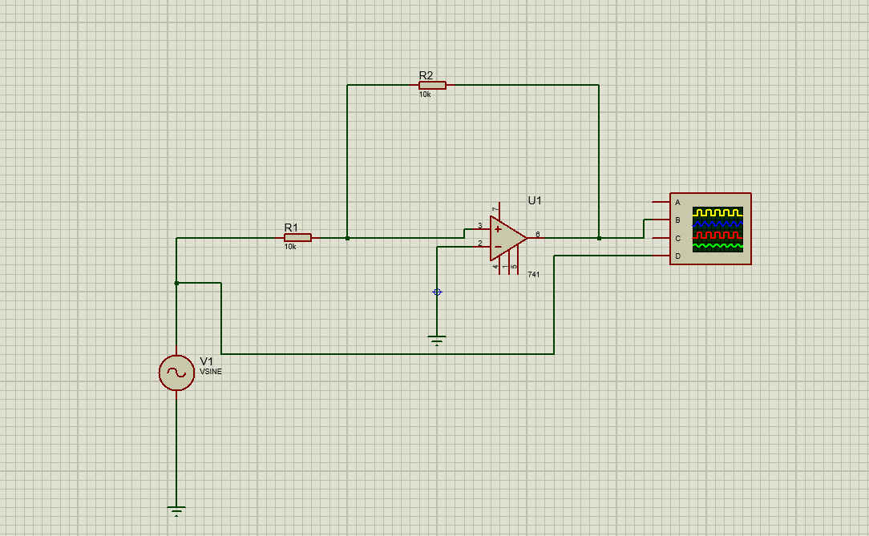
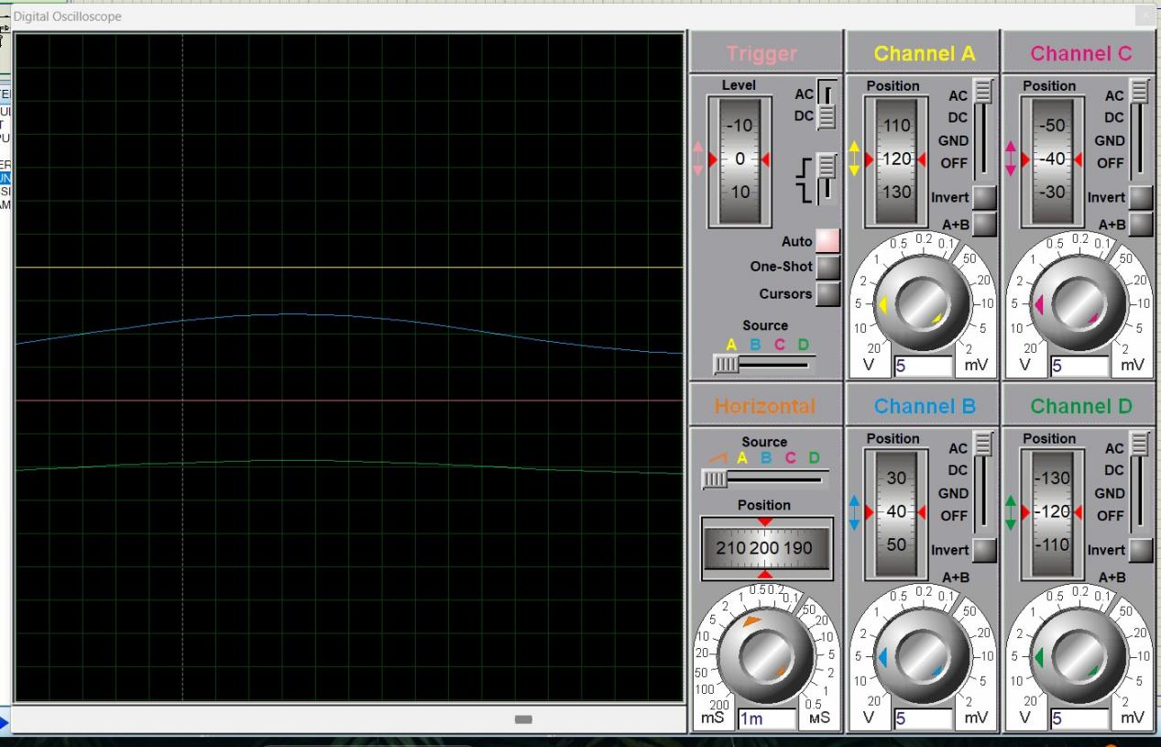
Explanation:
• This is also a 741 Op-Amp based circuit
• An AC sine wave input (V1) is applied
• R1 (10kΩ) connects the input signal to the non-inverting (+) terminal
• The inverting (–) terminal is connected to ground
• R2 (10kΩ) connects output back to the + terminal
➤ This is positive feedback
• Since R1 = R2, the feedback is stronger and symmetric
➤ This creates balanced switching levels
• The circuit again works as a Schmitt Trigger (comparator with hysteresis)
• Working:
- When input exceeds upper threshold, output goes HIGH (positive saturation)
- When input goes below lower threshold, output goes LOW (negative saturation)
• Due to equal resistors:
➤ Threshold levels are more stable and symmetric around 0V
• Input vs Output:
- Input = sine wave
- Output = clean square wave
• The oscilloscope shows:
- One channel = input sine wave
- Other channels = output square wave
• Main purpose:
➤ Convert analog signal into a stable digital signal with less noise effect
• Key difference from previous circuit:
➤ Here R1 and R2 are equal (10kΩ) → better symmetry and cleaner switching

Result:
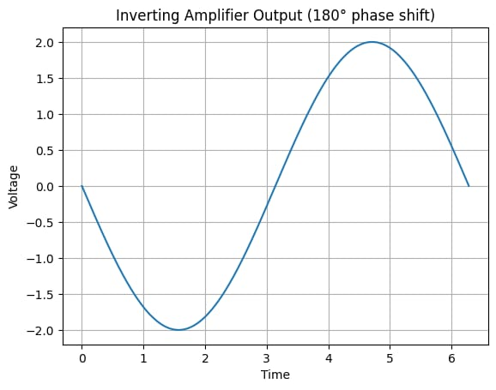
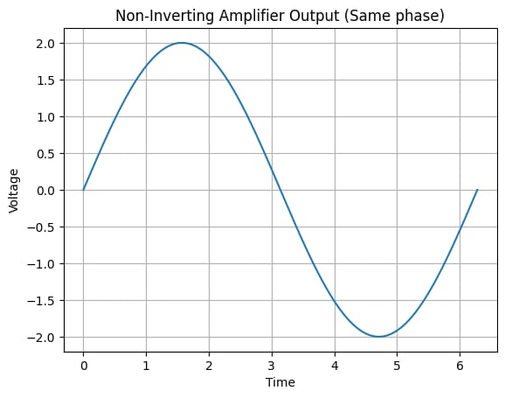
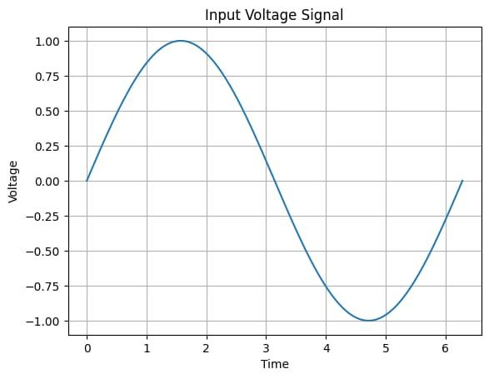
Questions/Answers
- Define inverting amplifier.
Ans:An inverting amplifier is an op-amp circuit in which the input signal is applied to the inverting (–) terminal, and the output is 180° out of phase (inverted) with respect to the input.

2. Define Non-inverting amplifier.
Ans:A non-inverting amplifier is an op-amp circuit in which the input signal is applied to the non-inverting (+) terminal, and the output is in phase (same shape and direction) as the input.

- What are the applications of inverting amplifiers?
Ans:Applications of Inverting Amplifier
- Signal inversion (flipping signal polarity)
- Summing amplifier (adding multiple signals)
- Integrator circuits
- Differentiator circuits
- Audio and signal processing

- What are the applications of non-inverting amplifiers?
Ans:Applications of Non-Inverting Amplifier
- Voltage follower (buffer circuit)
- Amplifying weak signals without changing phase
- Sensor signal conditioning
- Impedance matching
- Instrumentation systems

- What is gain of an amplifier?
Ans:The gain of an amplifier is the ratio of output voltage to input voltage.
It shows how much the signal is amplified.

6. How do you calculate the gains for inverting and non-inverting amplifiers?
Ans:Gain Formulas
- Inverting Amplifier Gain:
Av=−RfRinA_v = -\dfrac{R_f}{R_{in}}Av​=−Rin​Rf​​
➤ Negative sign shows phase inversion
- Non-Inverting Amplifier Gain:
Av=1+RfRinA_v = 1 + \dfrac{R_f}{R_{in}}Av​=1+Rin​Rf​​
➤ Output remains in phase

